Mid-course Assignment: 1 Week Forecast Challenge!
Geog 314U, Summer 2019

Due July 29, 2017 at 5 pm Pacific Time to the D2L dropbox.

This assignment is worth 25% of your final grade. You can find a scoring rubric at the bottom of this document

Goal One: Learn the process of creating a forecast by answering the questions:
- What (impacts) could happen to my community?

Goal Two: Learn how to assign confidence in a forecast by examining several likely future outcomes and answer the questions:
- Why (atmospheric processes) could the forecasted impact happen?
- How likely is the forecasted impact on my community to occur?

Goal Three: Learn how to verify your forecast after the fact, and evaluate your own accuracy as a forecaster.

Glossary:
- QPF: Quantitative Precipitation Forecast. A number expressing how much precipitation will accumulate during a specified period of time, typically 24 hours.
- QPE: Quantitative Precipitation Estimate. A number expressing how much precipitation actually occurred (best estimate because even rain gauges are not perfect) during the specified period of time. Must be generated after the precipitation event happened.
- Valid period: The time period accumulation is occurring. Has a start time and end time, or two of the three out of start time, end time, and accumulation period. The convention for QPF is to list the start time and the accumulation period and let the user calculate the start and end times accordingly. The convention for QPE is the list the end time and accumulation period and let the user calculate the start and end time accordingly.
- Verify / Verification: Compare QPF to QPE to evaluate the accuracy of the forecast. Can also refer to qualitative evaluation of forecasts. For instance, did the process I wrote down in my forecast discussion actually happen?
- Forecast Lead Time: The time, in days, from the forecast issue time until the end of the valid period.

Materials:
- Internet access (to look up forecasts and verifying data at the URLs below).
- Document software (MS Word, etc.) to create a forecast notebook.
- You should document each of the below steps in your forecast notebook along with your predictions and verification.
- I will grade this assignment based on your forecast notebook. Your grade will not be based on the accuracy of your forecast, it will be based on the thoughtfulness and consistency of the process you have documented in the notebook, so be thorough!
- Please write your name, city and forecast valid period at the top of the first page of your forecast notebook.

Steps:
- Look up NOAA Weather Prediction Center’s (WPC) 5-Day Quantitative Precipitation Forecast (QPF) with a valid start time between 12Z Monday, July 22 and 06Z Wednesday, July 24 To find this forecast, visit https://www.wpc.ncep.noaa.gov/qpf/day1-7.shtml and click on the thumbnail image for “5-Day Total Precipitation”.

IMPORTANT: You need to perform steps 1-9 on either Monday July 22 or Tuesday July 23 so that you do not miss the window of valid start times between 12Z Monday, July 22 and 06Z Wednesday, July 24. If your forecast has a valid period start time outside this window, 3 points will be deducted from this assignment.

You should see an image similar to the one below
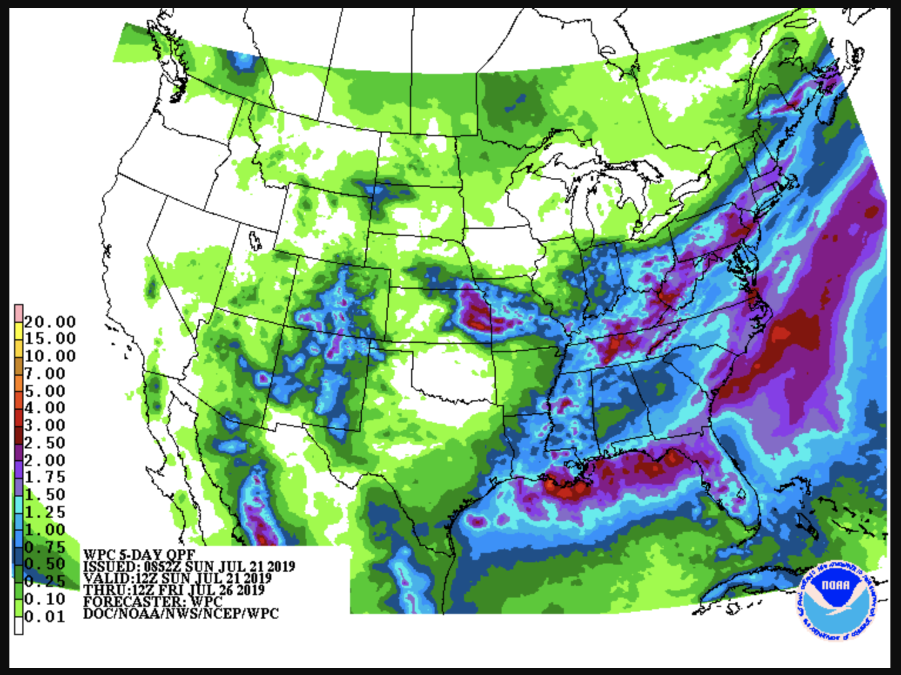

Check the time and date that is printed in the legend in the lower left part of the image after the word “VALID”. Make sure the VALID time falls in the time window printed above.

Make sure to save the image and add it to your forecast notebook.

- Choose a city from the map that is expected to receive significant precipitation in the next seven days. You may consider 2 inches or more as significant for the purpose of this assignment. You may need to use google maps or similar to visually match a “blob” of significant precipitation to a city.

- Look up your chosen city Daily Climate Report. This process is the same as for the weather journal, but may be for a different city based on what you choose in step 2 above. This link will take you to a page where you can look up Daily Climate Reports for groups of cities by clicking on a map. Find the “Normal Value” of daily precipitation for your city and mark this down. This is the average 24-hour accumulated precipitation (AKA Climatological 24-hour Quantitative Precipitation Estimate - “QPE”) for your city.

- Revisit the WPC QPF page and look through the forecasted 24 hour accumulated amounts (QPF) for day 1, day 2, day 3, and days 4-5. Note in the latter case, the accumulated amount will be for 48 hours, but we will ignore this discrepancy for the purpose of this exercise. You can find the QPF images broken down by Day 1, Day 2, etc. in the table below the heading “Quantitative Precipitation Forecasts” in red font. Each link should bring up an image similar to that from step 1. Choose the period (Day 1, Day 2, Day 3, Days 4-5) with the greatest accumulated precipitation over your city. This will become your Forecast Lead Time.

- Check to see if the 24 hour QPF for your city and chosen forecast lead time is greater than the climatological 24-hour QPE. If not, repeat steps 2-5 until you have found a city and 24-hour QPF that is greater than the climatological 24-hour QPE. Now, record the information from steps 2-4 in your forecast notebook.

- Record the WPC 24-hour QPF for your chosen forecast lead time. This is your baseline forecast for the precipitation expected in your city. Also write down the period of time this forecast is valid for. For example, If the WPC forecast from step 1 is valid 00 UTC on July 23, and you have chosen Day 3 as your forecast lead time, then your forecast will be valid for the period 00 UTC on July 25 through 00 UTC on July 26. “Day 3” here refers to the number days until the end of the rainfall. So, count forward 3 days from the time in step 1 to get the end of your forecast valid period. Then, count backward 24 hours to get the start of your forecast valid period. You can also find the valid period on the WPC Day X forecast image itself by looking at the “VALID” and “THRU” entries in the legend. See red box in the below example. Note that your VALID and THRU times will differ.

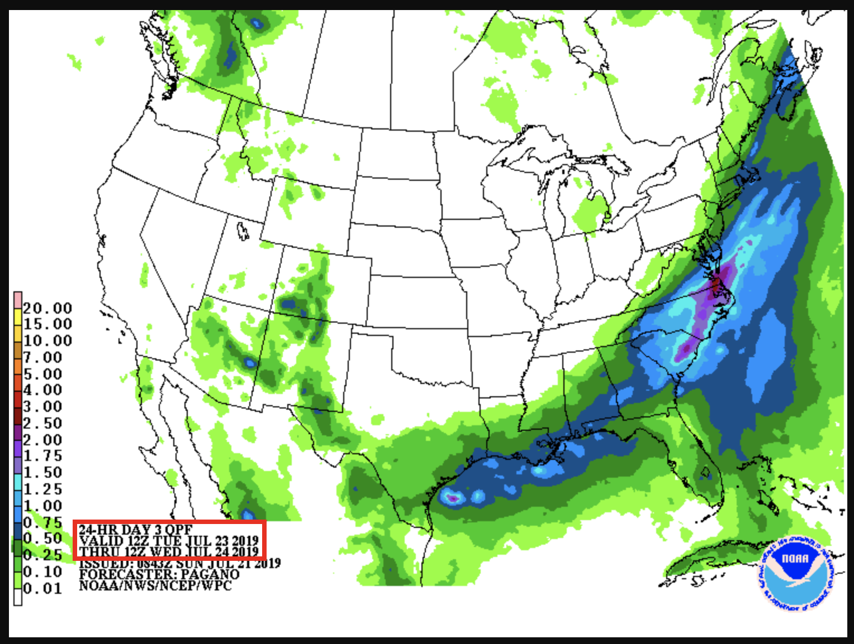

- Write down some climate and water infrastructure expectations for precipitation in your city. Is your city typically rainy during this part of the summer? What kind of weather events are you aware of that might produce heavy rain in your city during July? Examples might be “Thunderstorms”, “Hurricanes”, “Extratropical Cyclones”, “Atmospheric Rivers”, “Monsoon”, etc. Based on what you know about your city, what are the possible impacts of the 24-hour QPF amount you wrote down in step 6? Is it possible that there might be urban flash flooding, flooding of creeks and rivers, is there mountainous terrain that might amplify flooding? Is your city in a low-lying area so that the city’s systems may have trouble routing water away from neighborhoods and roads?

- Examine two other forecasts for 24-hour QPF for your city and forecast lead time, other than WPC’s forecast. These are your “ensemble members”. You will group them with your WPC baseline forecast to create an ensemble of 3 forecasts. Some example places to look for this information are:

  - Weather Underground’s 10-day forecast for your city
  - The National Weather Service River Forecast Centers (more maps like WPC)
  - One of several models available on tropical tidbits (we will review how to use this site in class)

Write down your two other forecasts. Note how similar or dissimilar each of them are. Very dissimilar forecasts are an indicator of low confidence.

- Use either the
  - WPCs day 1-7 significant weather type forecast https://www.wpc.ncep.noaa.gov/#page=ovw
  - Or Tropical Tidbits model forecast variable maps
To develop a forecast discussion for the weather processes that may lead to significant precipitation in your city at your chosen forecast lead time. This discussion should be around one paragraph and should include things like: any change in airmass, any mechanism for lifting or generating upward vertical motion (updrafts), or any expected conditional instability in the area. You should also focus on changes, meaning you should briefly discuss the current conditions in contrast to the expected conditions that might lead to significant precipitation. It will be helpful (though not required) to save an image or two from the above websites in your notebook to refer to in your discussion and later during step 10. End your discussion by writing a numerical prediction for 24-hour QPF (in inches) for your city and forecast lead time. Finally, place a confidence level on your prediction. The confidence level should be based on your ensemble of forecasts and on the type of process you expect to cause the precipitation. Is this a process that is common in your city during July? Has it happened recently, or will this be the first time this process has happened here in several weeks? We will walk through this in class too.

- Verify your forecast and evaluate how well you identified why it would occur. The process of forecast verification is comparing observations of what actually occurred to the forecast you made for the same place and valid time period (same as the forecast lead time period you chose in step 4). This is a three-step process.
  - Step One: Find the WPCs 24-hour QPE analysis. Follow the link and choose the “archive” button to get your verifying QPE. Make sure to choose the date that matches the end of your forecast lead time window from step 4. If you are unsure, look at the field “Valid” in the image that comes up. For QPE, valid refers to the end of the 24-hour period. This time should match the end of your forecast lead time period. Note that you will have to wait one day after your forecast lead time window has passed to retrieve this information. The map that opens will have 24-hour accumulated precipitation amounts printed as numbers of varying color. The maps allows you to zoom. Zoom in to a region centered on your city until the numbers are easily legible. Write down the 24-hour QPE that actually occurred. You may have to visually estimate between a cluster of numbers if no number is positioned exactly over your city.
  - Step Two: Compare your verifying 24-hour QPE to your predicted QPF. Were you correct? How different are the numbers?
  - Step Three: Identify potential reasons your forecast was not accurate. DO THIS EVEN IF YOUR QPF AND QPE MATCH EXACTLY. Use the GFS analysis variables on Tropical Tidbits and/or the NOAA Surface Analysis for the valid date of your forecast to compare to your forecast discussion. Did the processes you expected to happen actually occur? If not, did the fact those forecast processes turned out differently in reality affect the rainfall? Write a sentence or two about this in your journal. We will walk through the verification step in class on Wednesday, July 24. You may want to wait until after this date to perform this step yourself.

Rubric
Goal | Steps Performed | #Points Possible | #Points Awarded
1: Impacts | 1-6 | 30
2: Process and Confidence | 7-9 | 40
3: Verification | 10 | 30
Total |  | 100

