Experiment #1
Nanoparticulate Dye-Sensitized Solar Cells

Coordinator: Carl Wamser Experiment: Keith James Room: SB1-326
Solar cells based on nanoparticle semiconductors have the potential to replace silicon cells if they can be made to be both inexpensive and efficient. This experiment will investigate nanoparticle semiconductor electrodes that have been coated with a light-absorbing dye (photosensitizer).
Nanocrystalline (anatase) titanium dioxide is commercially available or is easily made by sol-gel processing. TiO2 is a wide-band-gap semiconductor, in that it absorbs only in the ultraviolet. It can be sensitized by adsorbing on its surface a dye that absorbs in the visible, e.g., a porphyrin functionalized with carboxy groups that bind tightly to TiO2. Upon light absorption, an electron is injected from the dye into TiO2, where it can be conducted to the underlying electrode. The circuit is completed by a redox solution that effectively shuttles electrons back and forth between the oxidized dye and the counter electrode.
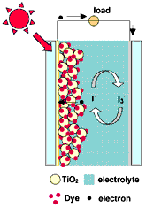
Experimental
In this experiment, students will coat a transparent electrode with TiO2 nanoparticles and fuse them into a high-surface-area semiconductor electrode. A porphyrin dye will be adsorbed and the extent of coverage determined by visible spectroscopy. The cell will be assembled with a redox electrolyte solution and a counter electrode, either coated with a catalytic amount of platinum or a thin film of polyaniline, a conductive polymer. The solar cell will be irradiated with light of standard intensity (to simulate sunlight), allowing for monitoring photocurrent, photovoltage, and overall energy conversion efficiency.

References
“Demonstrating Electron Transfer and Nanotechnology: A Natural Dye-Sensitized Nanocrystalline Energy Converter”, G. P. Smestad and M. Grätzel, J. Chem. Educ., 1998, 75(6), 752-756.
“Adsorption and Photoactivity of Tetra(4-carboxyphenyl)porphyrin on Nanoparticulate TiO2”,
S. Cherian and C. C. Wamser, J. Phys. Chem. B, 2000, 104, 3624-3629.
“Basic Research Needs for Solar Energy Conversion”, U.S. Department of Energy, 2005.
Note - all of the above references can be found as .pdf files on Professor Wamser’s website:
http://chem.pdx.edu/~wamserc/Research/
Experiment #2
Soft Lithography: Micromolding and Nanopatterning

Coordinator: Shalini Prasad Experiment: Ravi K. Reddy Room: SB2-405

Photo-Lithography Technique for fabrication of Micro Electrode Array:

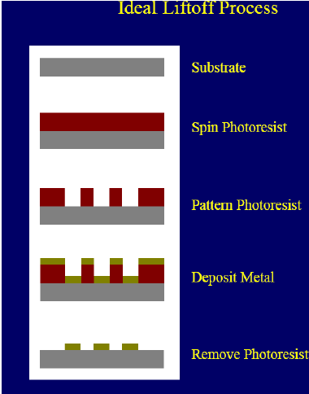
Photolithography is the process of transferring a pattern from a photomask master onto the surface of a silicon wafer or substrate. The pattern is transferred via an intermediate photosensitive polymer film called photoresist. Photolithography has been used for a long time in many different areas. One area that relies heavily on this practice is microfabrication. This serves a two-fold purpose. First it permits intricate details to be transferred to a substrate. Second, it allows multiple devices to be patterned at once. The idea is rather simple. (a)A pattern is laid out by the designer. This pattern is copied and repeated several times onto a photomask master. (b) The substrate that will use the pattern is coated with positive photoresist. (c)The mask is aligned to the wafer and exposed using the mask aligner (OAI Model 200). (d) The substrate is then placed in the developer solution which causes the pattern to appear in the resist film. (e) The metal is then sputtered on the substrate and using lift off we get rid of the Photo resist.
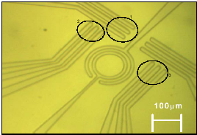
Micro Electrode Array fabricated in the BMNL.

Fabrication of the Cylindrical Structures with high aspect ratios on Silicon using SU8-50:

SU-8 is a high contrast, epoxy based photoresist designed for micromachining and other microelectronic applications, where a thick chemically and thermally stable image is desired. The exposed and subsequently cross-linked portions of the film are rendered insoluble to liquid developers. SU- 8 has very high optical transparency above 360nm, which makes it ideally suited for imaging near vertical sidewalls in very thick films. SU-8 is best suited for permanent applications where it is imaged, cured and left in place.
The Steps involved in Fabrication:
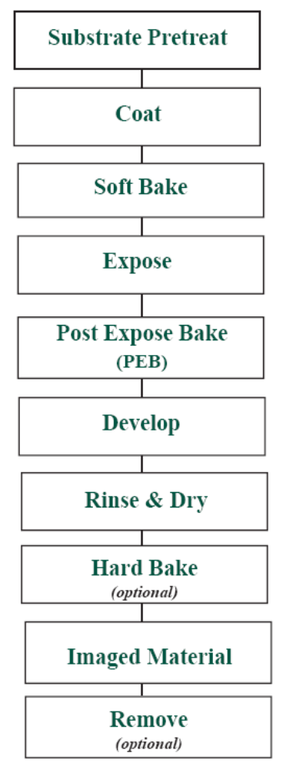
The experiment will cover making of the structures with high aspect ratios using the parameters like temperature of the soft bake, exposure time of the substrate.
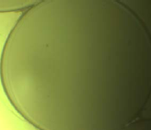
Cavity Micro resonator made at BMNL.

Experiment #3
Photolithography Software

Coordinator: Shankar Rananavare Experiment: Allen Chaparadza and Vindhya Kunduru
Room: SB1-308

Use of state-of-the-art software for photolithography applications

Modern semiconductor fabrication relies heavily on the use of photoresists to fabricate integrated circuits. Realization of Moore’s law has been in part due to the ability of photoresist manufacturer to provide resists that allow ever decreasing line-widths. The lecture will cover:
- Introduction to the basic photochemistry and kinetics of image development. This will involve studies of well-known resists based on diazo chemistry and chemically amplified resist used in DUV.
- A discussion of fundamental process parameters that are relevant for photoresist use such as surface-preparation, coating, optical/radiation exposure, developing, etching and resist stripping will be presented.
- Numerical simulations of resist profile using Prolith/3 software. This is meant to provide more quantitative assessment of resist performance useful in process development and research.
We will address emerging soft lithographic techniques and 193nm and EUV resists that allow nanometers resolution.

References:
(1) Semiconductor Lithography : Principles, Practices, and Materials (Microdevices :Physics and Fabrication Technologies) Wayne M. Moreau, General Technology Division, IBM
(2) Micro-And Nanopatterning Polymers (Acs Symposium Series, No 706) Hiroshi Ito(Editor)

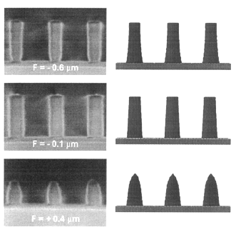
Comparison of simulated and experimental resist cross-sections through focus for 125°C,
90 seconds post-exposure bake.

Experiment #4
Focused Ion Beam

Coordinator: Erik Sanchez Experiment: Derek Nowak Room: SB2-449

Students will learn the inner workings of a focus ion beam (FIB) system, from individual components to the hands on operation. The lab section will cover the basic concepts of the vacuum system (pumps, process sequence, hands on and theory ), the ion beam column (lenses, sources, electronics), imaging theory for the FIB (how the image is made and how to optimize it). After learning the basic theory, students will operate the FIB (load/unload samples, obtain an
image). The FIB system is a Micron 2500 (5 nm imaging resolution) System is in Room 449, SBII. Lectures in room TBA.

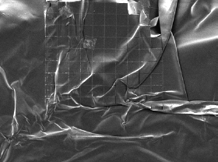

Experiment #5
Quantized Conductance in Nanocontacts

Coordinator: Raj Solanki Experiment: Lorie Noice and K. Parker Room: SB1-201

We describe an laboratory experiment on conductance steps observed to occur near integer multiples of 2e²/h as nanocontacts form and break between gold wires in loose contact. A op-amp circuit in conjunction with a storage oscilloscope suffice are used to observe the steps. The experiment may be extended by interfacing to a computer, which accumulates a histogram of conductance values as the wires are brought into and out of contact many times. The histogram shows peaks near integer multiples of 2e2/h. We will emphasize the pedagogical issues involved in this forefront condensed-matter physics research.

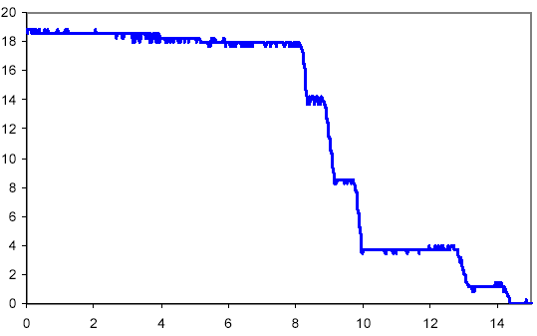
Quantized conductance

2e²/h
steps

Time (μs)

References:
Am. J. Phys 67, 389-393 (1999).
Costa-Krämer et al., Surf. Sci. 342, L1144 (1995).

Experiment #6
Electron Beam Evaporator

Coordinator: James Morris Experiment: Deepak Vedha Room: SB2-405

A “thin” film has traditionally been defined as one of thickness less than 1μm or 1000nm. Nanotechnology is arbitrarily defined by a dimensional limit of 0.1μm or 100nm, and thin metal films of thicknesses less than that show marked increases in electrical resistivity as the thickness becomes comparable to and less than the electronic mean free path. As electron scattering becomes more dependent on the thickness than thermal lattice vibrations, the temperature coefficient of resistance begins to reduce towards zero. These effects are greater for rough film surfaces (and diffuse electron scattering) than for smooth surfaces (and specular scattering.)

At film thicknesses below 10nm or so, the film may not be continuous, especially for noble or refractory metals (Au, Pd, W, etc) on insulators (SiO₂, glass, polymers, etc.) Examples of such films are shown below, for different average thicknesses of Au on glass [from Kazmerski & Racine.] Film (a) is the thinnest, and the gold islands are typically 2-5nm in diameter, separated by gaps of around 2nm. As more Au is deposited, in (b), the islands grow, touch, and coalesce, leaving spaces for new islands to nucleate. Such a film will display a bimodal distribution of island sizes. The process continues with (c) until metal filaments begin to form, and eventually a continuous electrical percolation path will provide metallic conduction between contacts.

Despite the absence of a continuous metallic path, all the films shown will conduct electrical current by electronic tunneling between islands, a quantum mechanical effect observable only at nm dimensions. The islands act as an array of “coulomb blocks,” which provide the fundamental basis of single-electron transistor operation. The process is characterized by an activation energy due to the finite electrostatic charging energy required by each island. You will deposit such a film in this experiment, and determine some of its properties in following exercises.
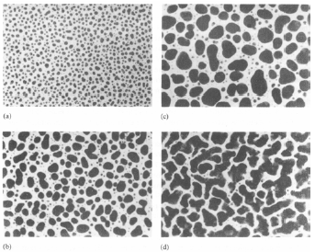
Thin films may be deposited in many different ways. Organic Langmuir-Blodgett films were an early example of molecular self-assembly. Chemical vapor deposition (CVD) is commonly used in VLSI fabrication, as is sputter-deposition, an example of physical vapor deposition (PVD). Thermal evaporation is another PVD technique, whereby the Au is evaporated by joule heating of the source. In electron-beam evaporation (EBE), the source material heating is localized to a spot which is raster-scanned across the source material surface. You will use EBE to deposit a film in the 1-10nm thickness range on a glass slide and a TEM grid.
The islands on glass will be observed by the AFM and SEM, (which will challenge the SEM.) The islands will be directly observed in the TEM, and their sizes measured by Debye-Scherrer broadening. Your data will be integrated with other groups’ results for possible publication.

Experiment #7
Soft Lithography: Polymer Microstructures by Self Assembly

Coordinator: Mingdi Yan Experiment: Kai Wang Room: SB1-224

Soft lithography is a non-photolithographic and inexpensive approach to micro- and nano- fabrication. In soft lithography, micropatterns are fabricated using an elastomeric stamp made of, for example, poly(dimethylsiloxane) (PDMS). The stamp contains three-dimensional structures molded onto its surface. Microstructures of organics, polymers, sol-gels, glasses and ceramics can be fabricated using a number of soft lithography techniques including microcontact printing (μCP), replica molding, micromolding in capillaries (MIMIC) and microtransfer molding (μTM). The patterns could be made in two- and three- dimensions on both flat and non-planar surfaces. Features of 30 nm have been delineated using soft lithography.

In this experiment, you will learn the technique of making PDMS stamps from a master mold. The mater mold is fabricated in Experiment 5 using the mask aligner. It contains arrays of microstructures that will be transferred to the PDMS by a molding procedure.

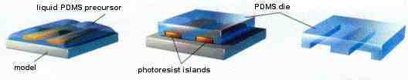

Subsequently, we will use PDMS stamps and the soft lithography technique of microcontact printing to fabricate patterned organic microstructures by a self-assembly process. The substrate will be gold films obtained from EBE (Experiment 6).

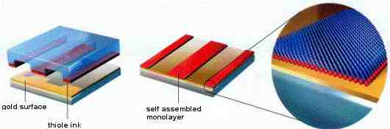

References
Xia, Y.; Whitesides, G. M. “Soft Lithography”, Angew. Chem. Int. Ed. Engl. 1998, 37, 551.

Experiment #8
Electrical Characterization of Bio/nanomaterials

Coordinator: Shalini Prasad Experiment: Vijay S. R. Kovvuri Room: FAB 25-02

For nanomaterial to serve as functional components in developing analysis systems, it becomes essential to electrically characterize such material. One of the high impact applications of nanomaterial has been in the area of biosensing. In biosensing systems the nanomaterial is essentially used as the sensing and transduction element. In order for the nanomaterial to successfully fulfill these functions, it needs to undergo a measurable change to a specific parameter associated with it.
One of the detection methods is to determine the change in the electrical parameters of the nanomaterial. In this experiment we are going to electrically characterize the properties of a specific nanomaterial namely carbon nanotubes
The goal of this experiment is to demonstrate a technique for electrically characterizing tow types of carbon nanotubes- multi walled carbon nanotubes and single walled carbon nanotubes based on variations to their conductance.
Aqueous suspension of multi and single walled nanotubes will be provided. PDMS stamps previously fabricated will be used to implement micro contact printing. Linear arrays of nanotubes will be stamped on to micro electrode arrays that have been previously fabricated. The electrical conductivity of multi and single walled nanotubes will be measured using micro manipulator probes in contact with the micro electrode array pattern using Lab View® controlled Data Acquisition System (DAQ). Continuous measurements will be taken over a period of 10 minutes in each case. The average conductance of both the types of nanotubes will be determined. Which is more conducting? Why?
Serum detection:
The nanotubes that exhibit higher conductivity are sonicated in Phosphate buffered saline solution and vortexed in fetal bovine serum. The serum coated nanotubes will b patterned in a manner similar to the uncoated tubs using contact printing techniques. The electrical conductance of these tubes will be measured. The variation to the conductance is a measure of serum accretion on to the tubes.
What are the inherent disadvantages of the technique? Is this technique selective?
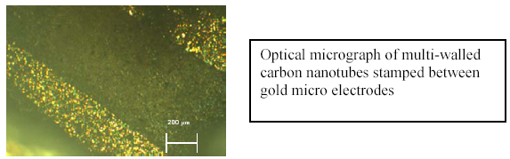
References:
- www.ni.com
- Lee et. al., “ Charge transfer from metallic single-walled carbon nanotube sensor Arrays,” 10.1021/jp056425v, J. Phys. Chem. B, 2006.

Experiment #9
Characterization using Atomic Force Microscopy

Coordinator: James Morris Experiment: Poornima Raju Room: FAB25-03

The atomic force microscope (AFM) is used in all research fields from semiconductor physics to life sciences to image physical structures in the study of material surface properties from the atomic to the micron level. It is also being applied in nanofabrication, by modifying layers or manipulating single atoms, molecules, or clusters. When the AFM probe is scanned over a small area of the sample surface, the force between the cantilever tip and the sample surface leads to bending or deflection of the cantilever, which is measured by photo-diode detection of a reflected laser beam (Fig. 1.)

Three modes of AFM operation are defined by the force-distance curve for the cantilever interaction (Fig. 2.) In the contact (repulsive) mode, the cantilever tip makes soft physical contact with the sample, and the repulsive ionic force generates the image as the cantilever is scanned over the surface. The contact mode works the best for hard materials, such as metals, ceramics, and most polymers, and where the surface topography does not have abrupt edges or tall steep features. The non-contact mode is one of several vibrating cantilever techniques for which the van der Waals, electrostatic, magnetic, or capillary force is used to produce the image of soft or elastic samples. The tapping (or intermittent-contact) mode is similar to the non-contact mode, except that the vibrating cantilever tip is closer to the sample and just barely hits or taps it. Tapping- mode cantilevers work well on all surfaces, especially organic and polymer coatings.

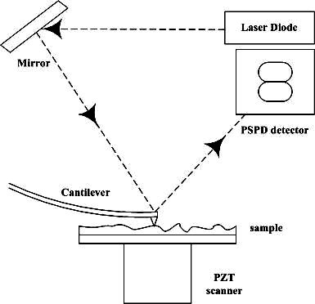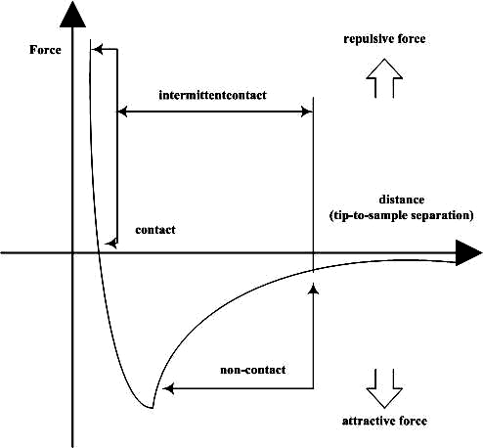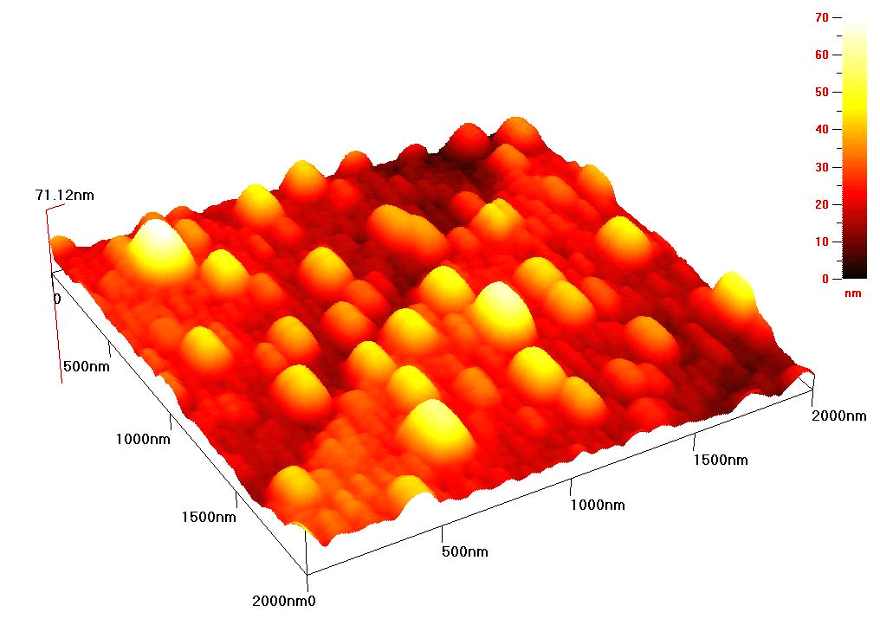

Fig. 1 Position detection of the Fig. 2 Interatomic force vs. Fig. 3 PbSe quantum dots (Physics)
the cantilever. Distance

In this experiment, you will set up the AFM with a known calibration sample, and then use it to examine specimens you prepared earlier in the course, specifically the metal islands of the discontinuous thin film, which will also be studied in the TEM and SE.

Experiment #10
Scanning Electron Microscopy and Energy Dispersive X-ray Spectroscopy

Coordinator: Chunfei Li Experiment: K. Asante Room: SB1-38

Scanning Electron Microscope (SEM) is a powerful tool to explore the microworld invisible to human naked eyes. Among many other tools that are available for microscopy purpose, SEM stands out due to its ease to use and high resolution. The resolution of optical microscope is limited to submicrometer order and that of SEM is in nanometer. We say nanometer resolution is higher than micrometer though one nm is substantially smaller than one um. Compared to the sample preparation process of transmission electron microscope (TEM), which is another powerful tool, the sample preparation of SEM is relatively easy and straight forward (?). Question mark implies that this claim is open to discussion. The power of SEM is added up by its capability to combine with energy dispersive X-ray spectroscopy (EDS), allowing us to know not only the topography but also constituent elements.
This lecture begins with a brief introduction of the physical principle for SEM, followed by an introduction to the instrument with ISI-SS40 and FEI Sirion XL30 as detailed examples. Topics to be covered will include the generations of vacuum and electron beam, lens, aperture, working distance, stage, detector, chromatic and spherical aberration, recognition and correction of astigmatism. The necessity and technique used for coating will be introduced in the section of sample preparation. For EDS, the teaching sequence will be physical principle, instrument, qualitative, and quantitative analysis. The system manufactured by Oxford Instrument will be used as example. The concept of line scan, elemental mapping, and spectrum mapping will be explained. Lab will be in SB1, Room 38.

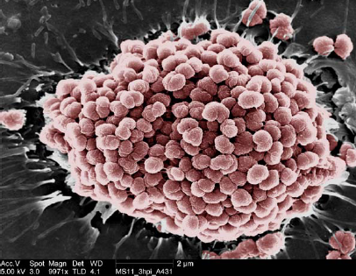
SEM image of Neisseria gonorrhoeae infection of human epithelial cells. Bacteria have been pseudo-colored to accentuate structural detail. Sample is supplied by Dr. Magdalene So of Oregon Health and Science University.

Experiment #11
Transmission Electron Microscopy and Nanometrology
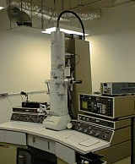

Coordinator: Peter Moeck Experiment: Girish Upreti Room: SB1-19

Sample preparation; introductions to diffraction contrast, high-resolution phase contrast, atomic resolution Z-contrast imaging; and electron diffraction; as well as some practical work will give you a good introduction to advanced structural transmission electron microscopy. Image-based nanocrystallography /nanometrology in two and three dimensions with on-line database support will also be discussed. As a result of this course you will be able to fully appreciate the images below. (This is a skill any good graduate student of the sciences or engineering should possess in order to fully comprehend the literature.)

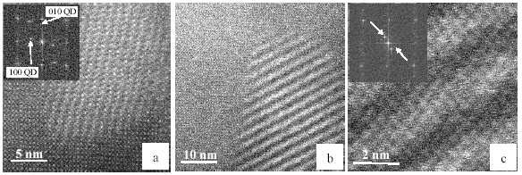
[001] atomic resolution Z-contrast STEM images of structurally transformed In(As,Sb) QDs in InAs matrix; (a) unidentified phase that possesses a lattice mismatch strain minimizing orientation relationship with the matrix; (b) periodic compositional modulation that may have arisen from spinodal decomposition; (c) same as (b) but in higher magnification, showing atomic steps in the compositionally modulated entities that are compatible with the two observed additional periodicities in the inset power spectrum; (The power spectrum clarifies that the modulation periodicity is not due to a moiré effect since there are actually two additional periodicities, marked by arrows. These two periodicities add up to a single compositional modulation parallel to ± [110] with a periodicity of 0.4 times the length of the vector (110) and may be explained as a lattice mismatch strain response); power spectra as insets in (a) and (c).

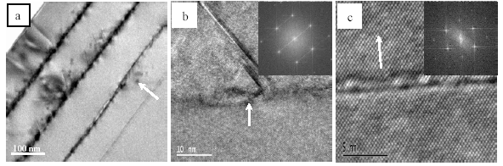
Sn_{x}Si_{1-x}/Si multilayer structures: (a) [110] cross section CTEM overview, x = 0.1, additional ex-situ anneal, the arrow is parallel to the growth direction and points towards one of many α-Sn QDs that grew within the Si layer; (b) [110] cross section HRTEM image, Sn_{0.1}Si_{0.9} layer (arrow) in Si and lattice defects on {111} and {111} planes, as deposited (i.e. only in-situ thermal treatments); (c) [110] cross section HRTEM image, perfectly pseudomorph Sn_{0.02}Si_{0.98} layer in Si, as deposited; power spectra in (b) and (c) as insets, (arrows indicate growth directions).
References:
P. Moeck, Atomic Ordering in Self-Assembled Semiconductor Quantum Dots, 2005, Special Issue on Nanotechnology Nanoscience and Nanobiology No 2(23) of the international journal Problems of Nonlinear Analysis in Engineering Systems 11 (2005) 48-65, edited by S. Santoli

Experiment #12
X-Ray Diffraction: Nanoparticle Size by Debye-Scherrer Method

Coordinator: S. Rananavare Experiment: Joo Room: TBA

X-ray Diffraction: Studies of Nanoparticles
To emphasize the role of molecular structure, a set experiments employing X-ray diffraction will be undertaken. Here the goal is to show, how rapidly and efficiently molecular crystal structures can be probed through X-ray powder diffraction technique. Students will investigate nano-sized antimony doped indium tin oxide particles. The complete experiment involves: (1) data collection on samples where particle size is systematically varied from 5-10 nms (2) data analysis using Debye-Scherr equation. Avery-Dennison R& D group has provided samples synthesized at variable pH (1, and 4 shown below) at no cost.
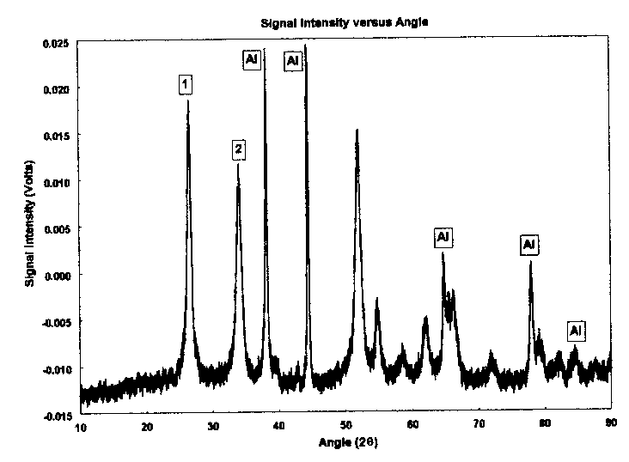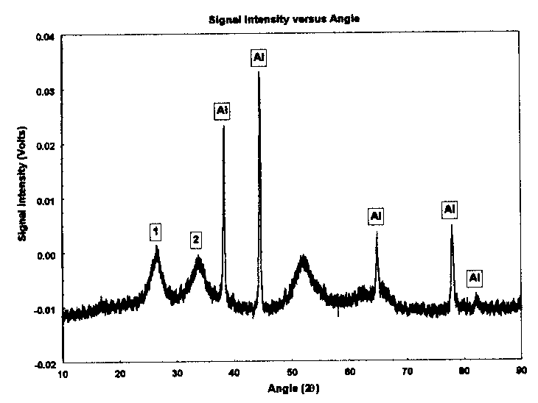
Work Supported by



